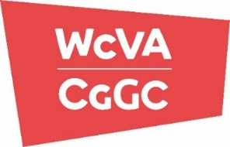
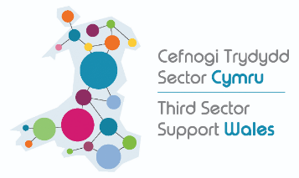

Winter Pressures Fund

Application form

Deadline for applications is 3pm on Tuesday 14th December 2021

Organisation name
Contact Name
Contact email address

Please provide an overview of the proposed activity.

To include:
- Clear description of the project activities with a brief timeline
- Who the funding will ultimately benefit

Please select the priorities this activity will directly contribute towards
Mental health
Physical health
Fuel poverty
Community transport
Food security
Other (please describe)

Approximate number of volunteers contributing to the funded activities | Approximate number of beneficiaries of the funded activities

Amount Requested - Please provide information on what will be paid for with the funding
Description | Cost
TOTAL (right click on number, update field - to update total) | £ 0.00

We also require a copy of a recent bank statement and governing document to complete the application process. Please ensure that copies of both documents are forwarded with your application to Ceri Venners at GVS by email: ceri@gvs.wales

